DNA Solution of Hard Computational Problems

Richard J. Lipton
Science, Vol. 268, Issue 5210 (Apr. 28, 1995), pp. 542-545

Abstract
DNA experiments are proposed to solve the famous “SAT” problem of computer Science. This is a special case of a more general method that can solve NP-complete problems. The advantage of these results is the huge parallelism inherent in DNA-based computing. It has the potential to yield vast speedup over conventional electronic-based computers for such search problems.

1. Method
1.1 At each stage, a path has exactly two choices: If it takes the vertex with an unprimed label, it will encode a 1; if it takes the vertex with a primed label, it will encode a 0. Therefore the path encodes the binary number 01.
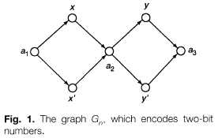
1.2.1 E (t, i, a) to denote all of the sequences in test tube for which the ith bit is equal to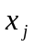 for a in {0, 1}.
1.2.2 Any SAT problem on n variables and m clauses can be solved with as most order m extract steps and one detect step.
1.2.3 For each literal 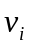, operate as follows: If is equal to , then form E(, j , 1); if equal to 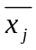, then form E(, j , 0).The reminder of each extraction is used for the next step. Pour all of these together to form 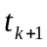. Then, do one detect operation on to decide whether or not the clauses are satisfiable.
2. Example
F = ( x y )( )
2.1 Let be the test tube that corresponds to E (, 1, 1). Let the reminder be and let be E (, 2, 1). Pour and together to form .
2.2 Let be the test tube that corresponds to E (, 1, 0). Let the reminder be . Let be E (, 2, 0). Again Pour and together to form .
2.3 Check to see if there is any DNA in the last test tube, .the satisfying assignments are exactly those in this final test tube.
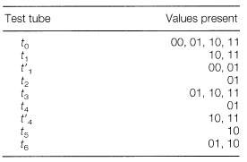
3. Result
The main open question is, of course, if one can actually build DNA computers based on the methods described here. The key issue is errors. The operations are not perfect.

Created by: Chia-Chang Wang
Date: Aug. 19, 2003

